Project RAG
Muhammad Hafizh Hakim
24523062
SJK - A

Yang Dikumpulkan
• Link GitHub repo (wajib updated)
- https://github.com/Huapiz/Project-RAG.git
- https://github.com/Huapiz/Project-RAG/tree/6c0be93a0a7043b20120747cc424490b9735c70b/cloudflare
• Screenshot DNS, Tunnel, Firewall rules, Analytics
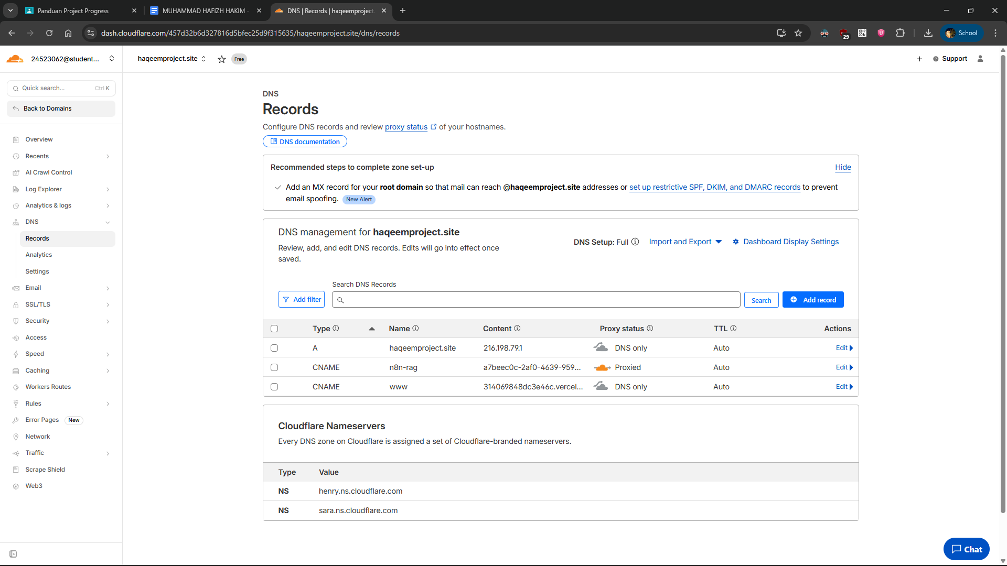
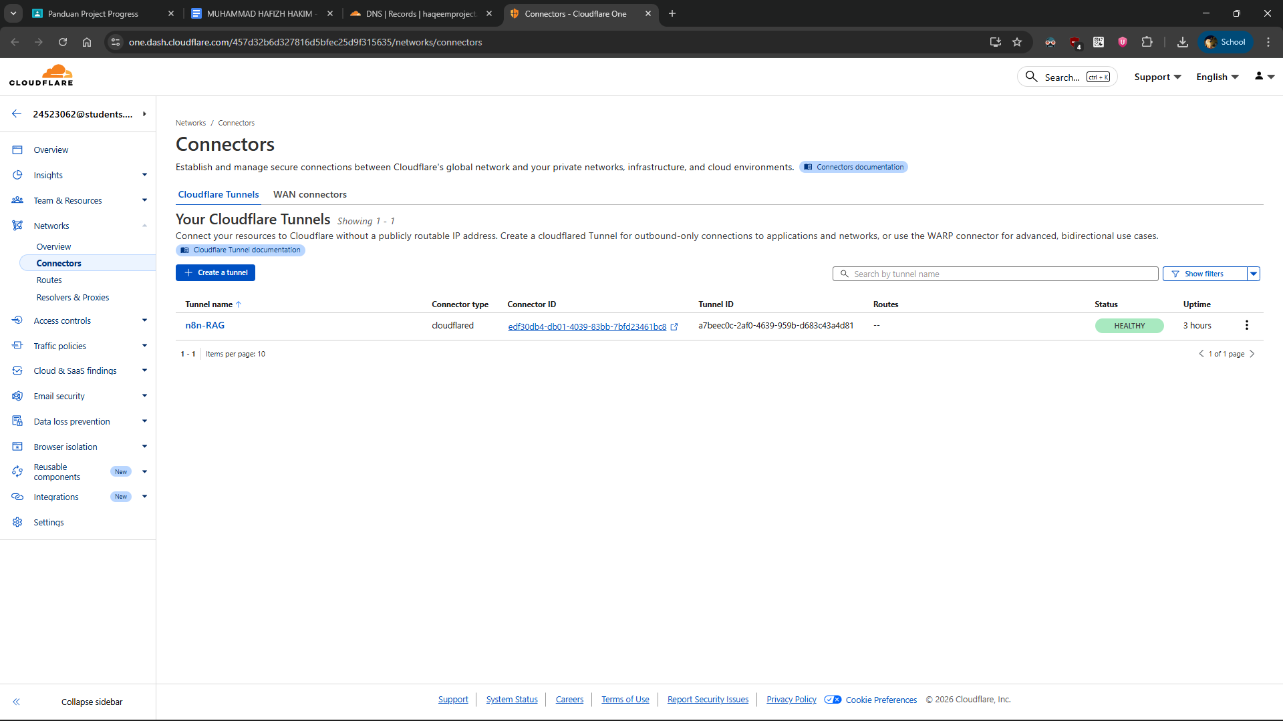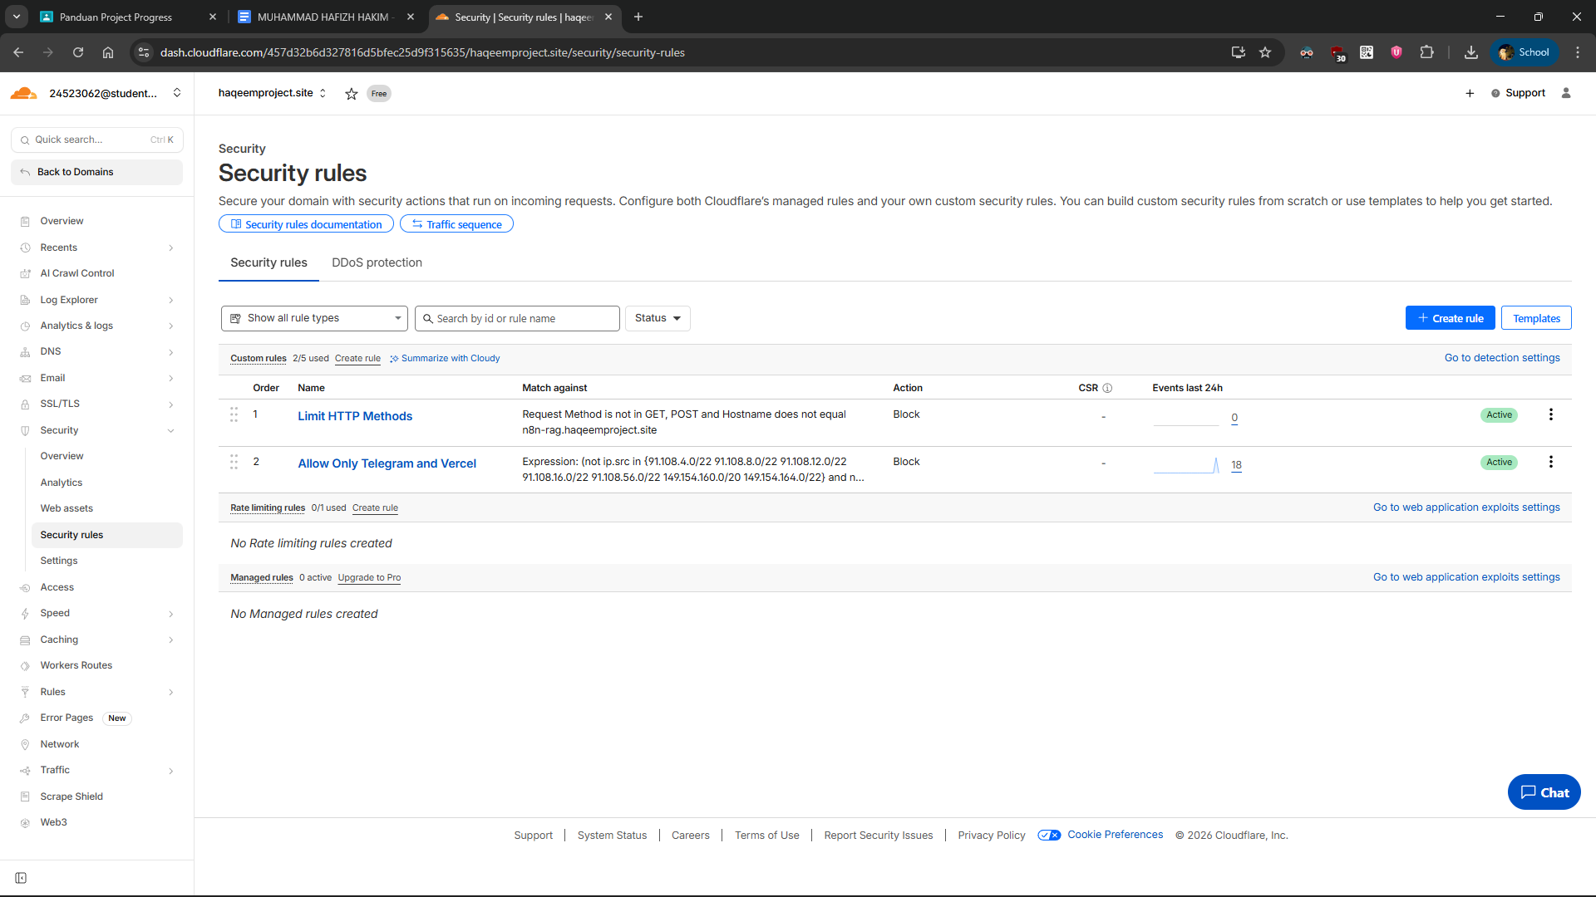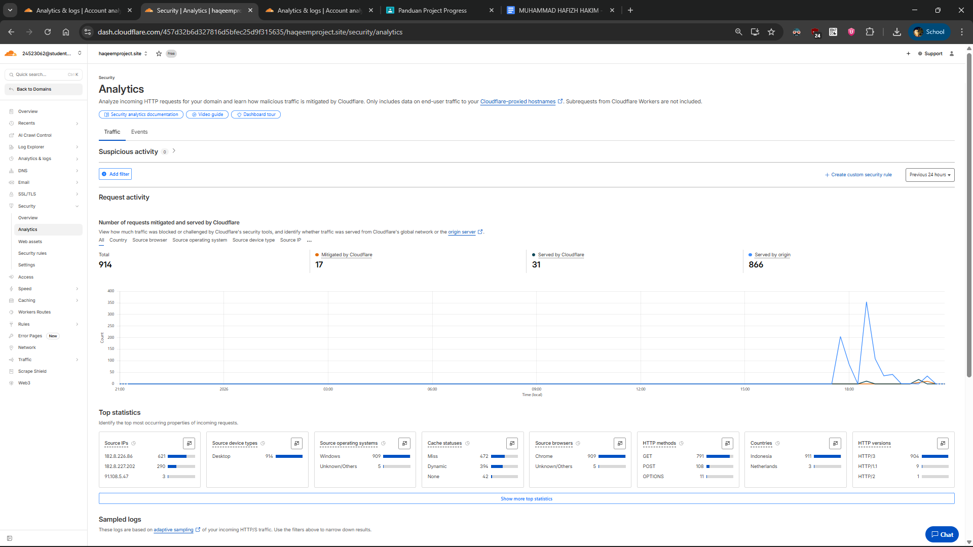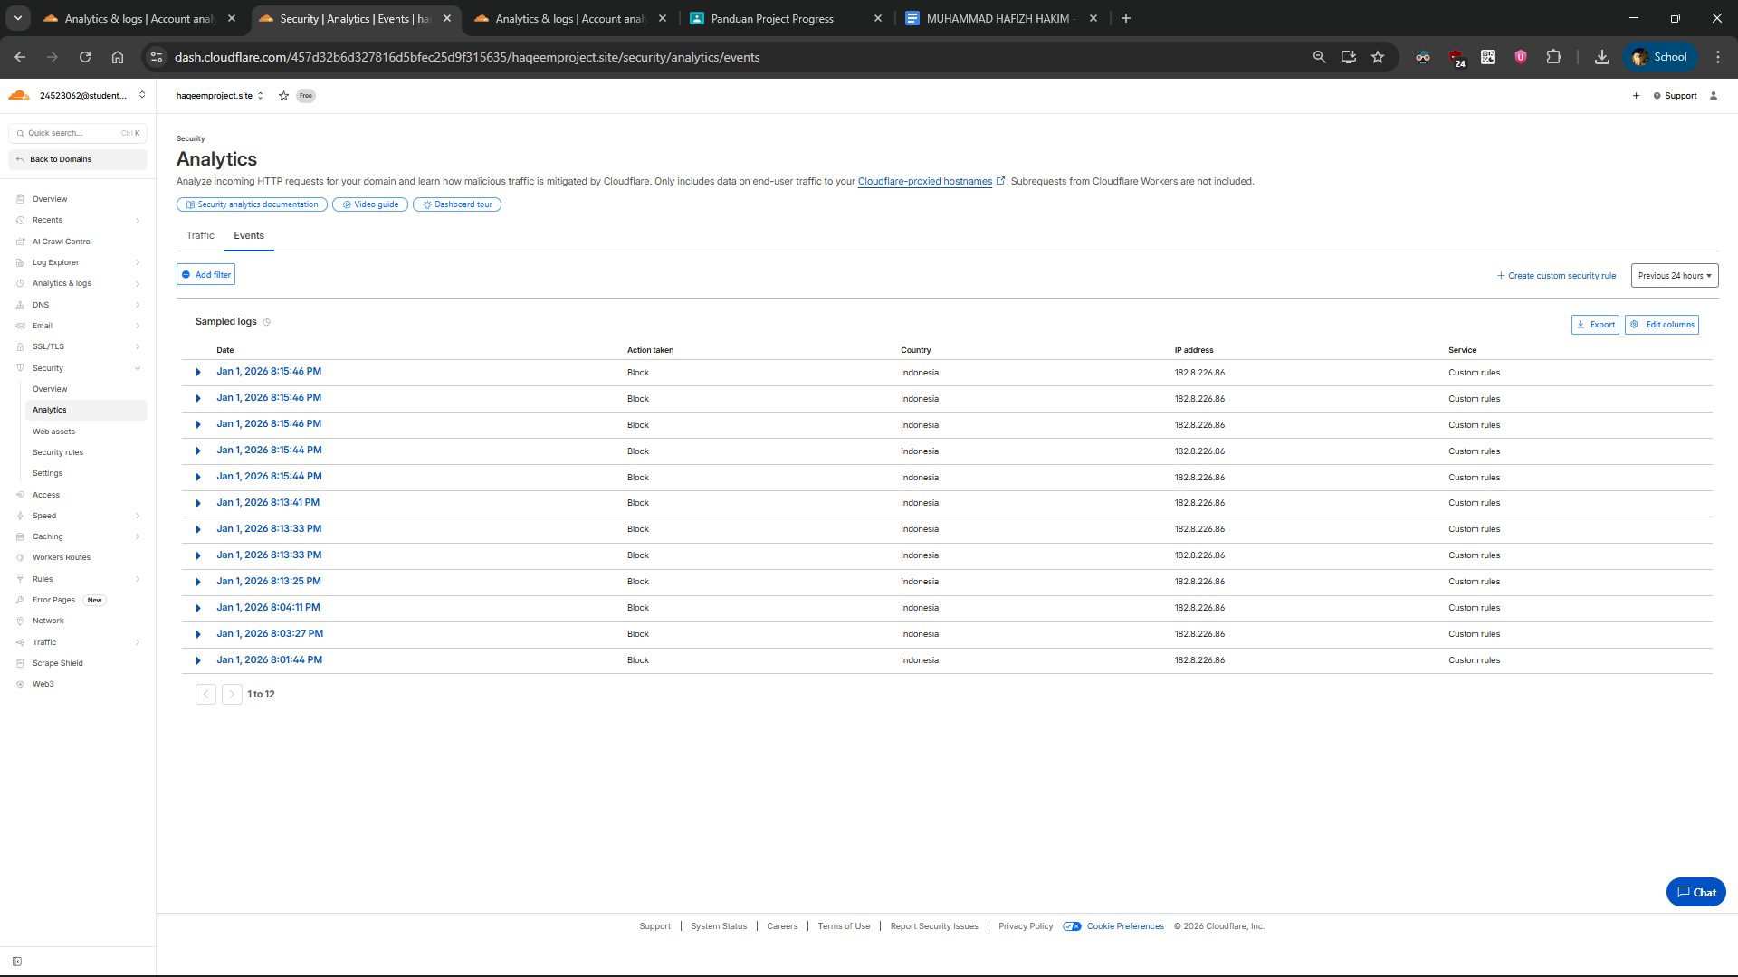

• URL n8n via Cloudflare
- https://n8n-rag.haqeemproject.site
• URL WebApp via Cloudflare
- https://www.haqeemproject.site

• Laporan integrasi Cloudflare (1 halaman)
Telah berhasil dilakukan migrasi dari Ngrok ke Cloudflare Tunnel dengan implementasi security rules untuk melindungi workflow n8n. Integrasi mencakup DNS management, tunnel configuration, dan firewall rules yang membatasi akses hanya dari sumber terpercaya (Telegram dan Vercel).

KOMPONEN YANG DIIMPLEMENTASIKAN

Cloudflare Tunnel
- Tunnel ID: a7beec0c-2af0-4639-959b-d683c43a4d81
- Service: n8n pada localhost:5678
- Hostname: n8n-rag.haqeemproject.site
- Webhook Endpoint:
https://n8n-rag.haqeemproject.site/webhook/fd301844-9511-46c9-87c0-5ceb9d51b42b
- Status: Active dan berjalan stabil

DNS Configuration
- haqeemproject.site: CNAME ke Vercel (untuk WebApp)
- n8n-rag.haqeemproject.site: Proxied melalui Cloudflare (orange cloud)
- SSL/TLS: Full encryption mode

Security Rules (Firewall)
Rule 1: Limit HTTP Methods
- Memblokir semua HTTP methods selain GET dan POST
- Melindungi dari attack methods (PUT, DELETE, PATCH)
- Exception: n8n-rag subdomain dapat menggunakan semua methods

Rule 2: Allow Only Telegram and Vercel
- Membatasi akses hanya dari IP Telegram (7 ranges) dan referer Vercel
- Memblokir akses direct dari browser atau unauthorized tools
- Melindungi webhook endpoint dari abuse

PERFORMA DAN ANALYTICS

Traffic Statistics (24 jam terakhir)
- Total Requests: 844 requests
- Cached: 24 requests (2.8%)
- Uncached: 820 requests (97.2%)
- Bandwidth: 14.14 MB total, 92.83 kB cached

Geographic Distribution
- Indonesia: 841 requests (99.6%)
- Netherlands: 3 requests (0.4%)

Security Analytics
- Total: 914 requests processed
- Mitigated by Cloudflare: 17 requests (1.9%)
- Served by Cloudflare: 31 requests (3.4%)
- Served by origin: 866 requests (94.7%)
- Blocked Events: 12 blocked attempts (dari IP non-whitelisted)

Content Types
- JSON: 39.52% (API responses)
- Form: 22.39% (webhook submissions)
- Empty: 19.91% (status checks)
- CSS: 13.27%

INTEGRASI WORKFLOW

Workflow 1 & 2 Updates
✅ Telegram webhook endpoint berhasil dipindahkan ke Cloudflare Tunnel
✅ WebApp Vercel terhubung via DNS CNAME
✅ n8n workflow berjalan normal dengan Pinecone Vector Store untuk RAG
✅ Ngrok telah dihentikan dan digantikan sepenuhnya

Architecture Flow
Telegram Bot → Cloudflare Firewall → Cloudflare Tunnel → n8n (localhost:5678)
↓
Pinecone Vector Store
↓
OpenAI API

KEAMANAN

Implemented Security Layers
- Network Level: Cloudflare DDoS protection
- Application Level: Custom firewall rules
- Access Control: IP whitelisting (Telegram IPs)
- Referer Validation: Vercel domain verification
- SSL/TLS: End-to-end encryption

IP Whitelist (Telegram)
- 91.108.4.0/22, 91.108.8.0/22, 91.108.12.0/22
- 91.108.16.0/22, 91.108.56.0/22
- 149.154.160.0/20, 149.154.164.0/22

REPOSITORY

GitHub Structure
/cloudflare/
├── tunnel-config.yaml
├── firewall-rules.md
└── Dokumen arsitektur

Commit: Pushed to GitHub repository dengan dokumentasi lengkap

KESIMPULAN
Integrasi Cloudflare berhasil dilakukan dengan hasil yang memuaskan. Sistem berjalan stabil dengan performa tinggi (1% bandwidth saved, 94.7% requests served from origin). Security rules efektif memblokir unauthorized access sebanyak 1.9% dari total requests. Migrasi dari Ngrok memberikan keuntungan dalam hal reliability, security, dan tidak ada batasan timeout.

Benefits Achieved
- ✅ Zero downtime migration
- ✅ Enhanced security dengan multi-layer protection
- ✅ Better monitoring via Cloudflare Analytics
- ✅ Cost optimization (Cloudflare Free Plan)
- ✅ Production-ready infrastructure

